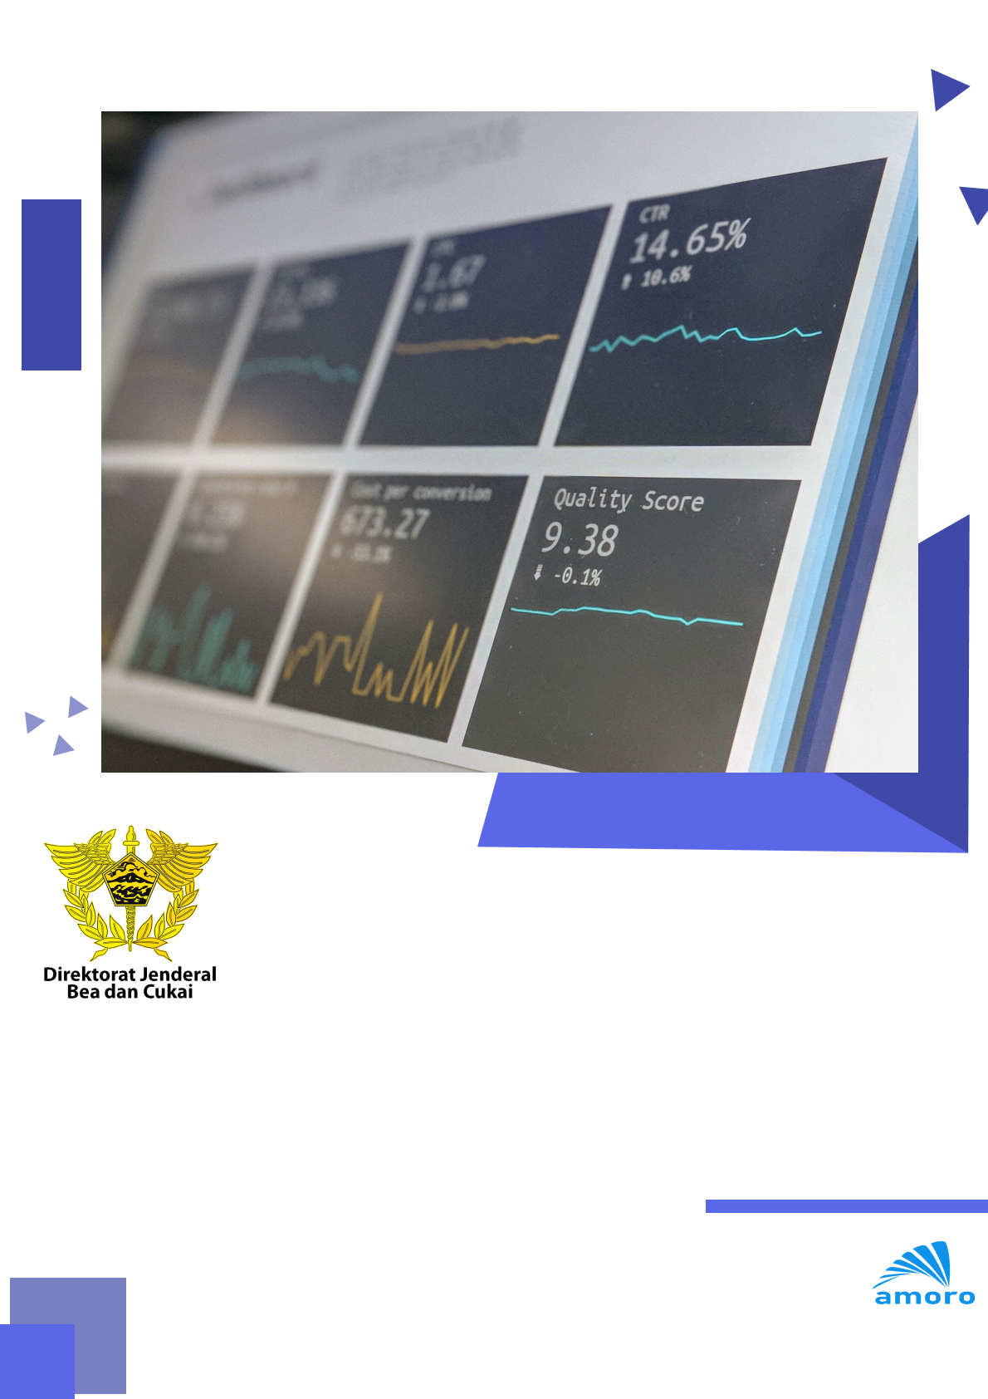

|  |
| --- |
| LAPORAN PEKERJAAN  DAILY MONITORING OPENSHIFT |

|  |
| --- |
| Prepared By: |

|  |
| --- |
| PT Amoro Technology Indonesia |

|  |
| --- |
| Cyber II tower Lt.18 |

|  |
| --- |
| www.amorotechnology.com |

infra0.proddc.customs.go.id

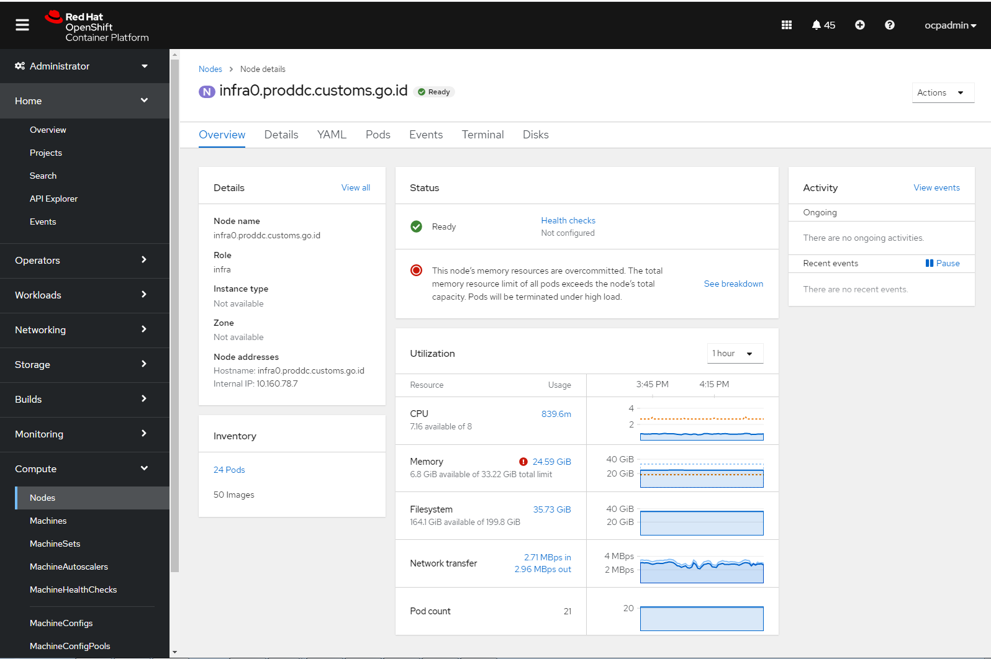

infra1.proddc.customs.go.id

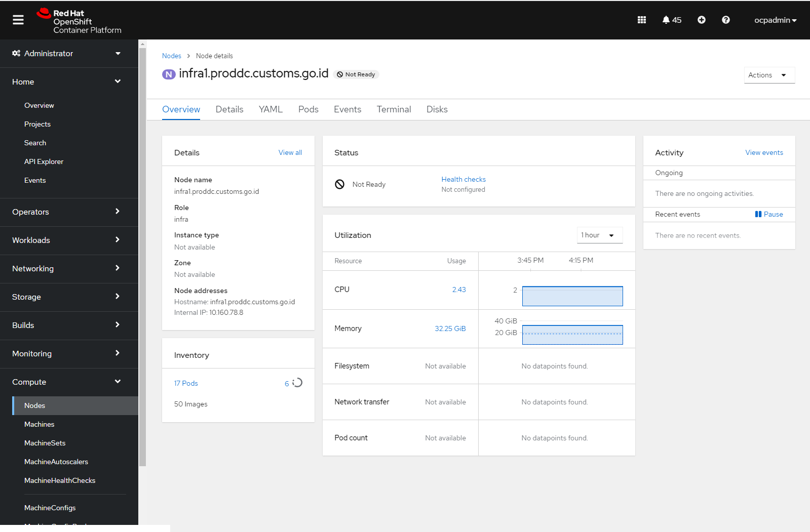

infra2.proddc.customs.go.id

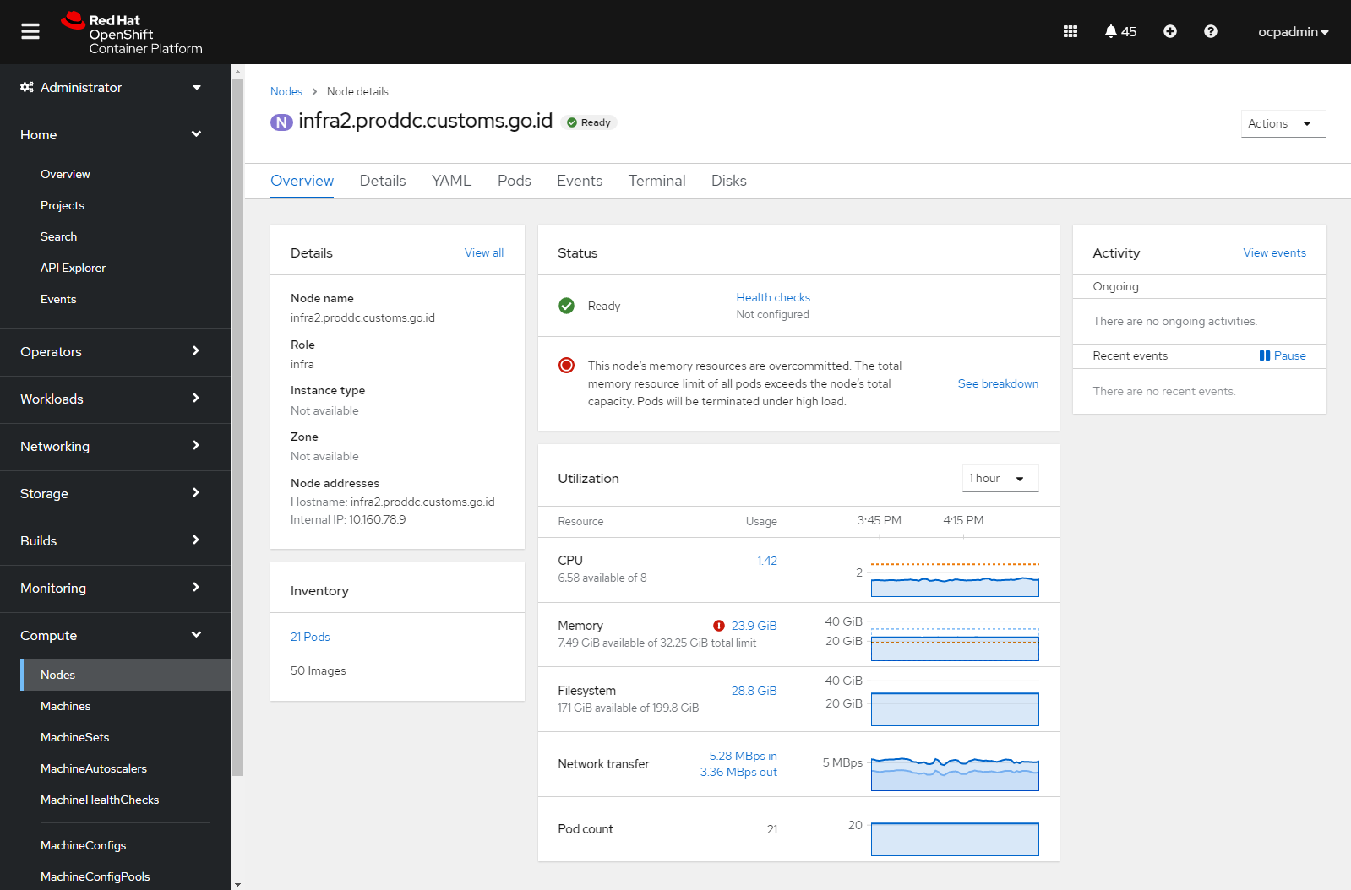

master0.proddc.customs.go.id

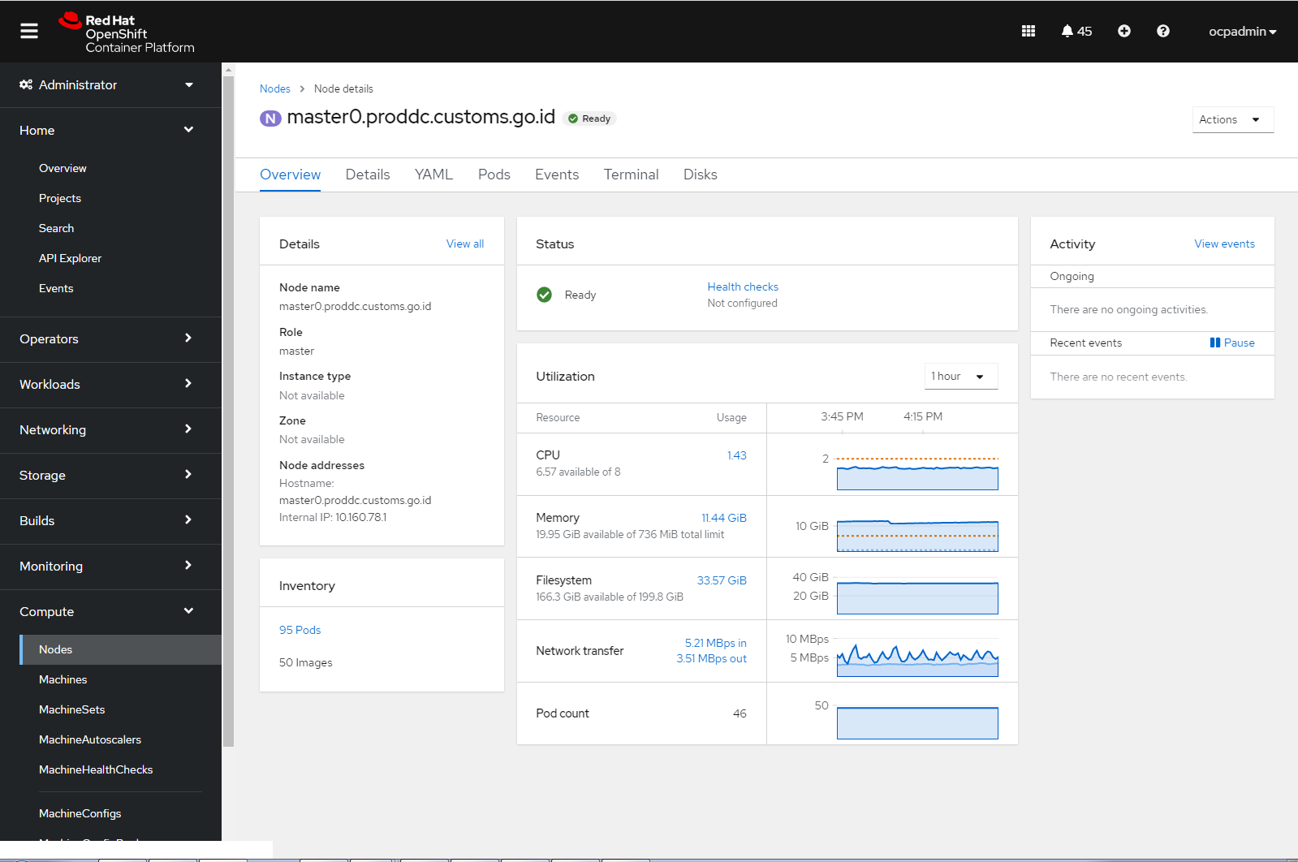

master1.proddc.customs.go.id

